NAME : SATHISH R
EMAIL : 727823tucs306@gmail.com
Community Event Management System
(File Upload Question – No-Code Application)

1. Introduction
Community centers often manage multiple events such as workshops, cultural programs, awareness sessions, and sports activities. Handling event details and registrations manually makes it difficult to track participants, send reminders, and maintain accurate records.
The Community Event Management System is a no-code web application designed to simplify event creation, registration, and communication. The system allows organizers to manage events efficiently while enabling users to register online and receive automated confirmations and reminders.

2. Problem Statement
A local community center needs a digital platform to:
- Create, update, and delete events
- Allow users to register for events online
- Manage registration details
- Send automated confirmation and reminder emails
Manual processes lack efficiency, cause data loss, and do not support timely notifications.

3. Objectives
- To design a simple and user-friendly event management system
- To enable online event registration using forms
- To store event and participant data securely
- To automate confirmation and reminder notifications
- To demonstrate file upload functionality in a real-world use case

4. System Overview
The system is built using no-code tools and integrates multiple platforms to handle UI, data storage, form submission, and automation.
Key Features:
- Event creation and management
- User registration for events
- File upload support
- Automated email confirmations
- Reminder notifications before events

5. Tools and Technologies Used
Tool | Purpose
ChatGPT | Brainstorming event types and registration flow
Notion AI | Project documentation and planning
Bubble | UI design and application logic
Airtable | Event and registration data storage
Jotform | Event registration form creation
Make | Automation of confirmation and reminder emails
n8n | Workflow automation for notifications

6. System Modules
6.1 Event Management Module
- Organizers can create new events
- Edit existing event details
- Delete cancelled events
- Upload event posters or images (file upload)
6.2 Event Registration Module
- Users can view available events
- Register by filling a form
- Upload optional documents during registration
- Receive confirmation after successful registration
6.3 File Upload Module
- Event image upload during event creation
- Optional document upload during user registration
- Files are securely stored and linked to records
6.4 Notification & Automation Module
- Automatic confirmation email after registration
- Event reminder emails before the event date
- Automated workflows using Make and n8n

7. Database Design (Airtable)
7.1 Event Table
Field Name | Data Type
Event Name | Text
Description | Long Text
Date & Time | Date
Location | Text
Organizer Name | Text
Event Image | Attachment
7.2 Registration Table
Field Name | Data Type
Participant Name | Text
Email | Email
Phone Number | Number
Uploaded File | Attachment
Event | Linked Record (Event Table)

8. User Interface Design (Bubble)
Pages Implemented:
- Home / Event List Page
  - Displays all upcoming events
  - Register button for each event
- Event Creation Page
  - Form for event details
  - File upload for event poster
- Event Registration Page
  - Displays selected event details
  - Registration form with file upload
- Organizer Dashboard
  - View events and registered participants

9. Workflow Explanation
Event Creation Workflow:
- Organizer fills event creation form
- Uploads event image
- Data is saved to Airtable via Bubble
Event Registration Workflow:
- User selects an event
- Fills registration form
- Uploads optional file
- Registration details stored in Airtable
Email Automation Workflow:
- New registration triggers Make / n8n
- Confirmation email sent to user
- Reminder email sent before event date

10. Advantages of the System
- Reduces manual work
- Improves data accuracy
- Enables real-time registrations
- Automated communication
- Easy to scale and modify
- No coding required

11. Limitations
- Depends on third-party tools
- Internet connectivity required
- Limited customization in free plans

12. Future Enhancements
- Admin authentication and roles
- SMS / WhatsApp notifications
- Event capacity limits
- Payment integration for paid events
- Analytics dashboard

13. Conclusion
The Community Event Management System provides an efficient, user-friendly solution for managing events and registrations. By using no-code tools and automation platforms, the system reduces manual effort, improves communication, and ensures organized data handling. This project demonstrates practical usage of file upload, database integration, and workflow automation in a real-world scenario.

BUBBLE IO:
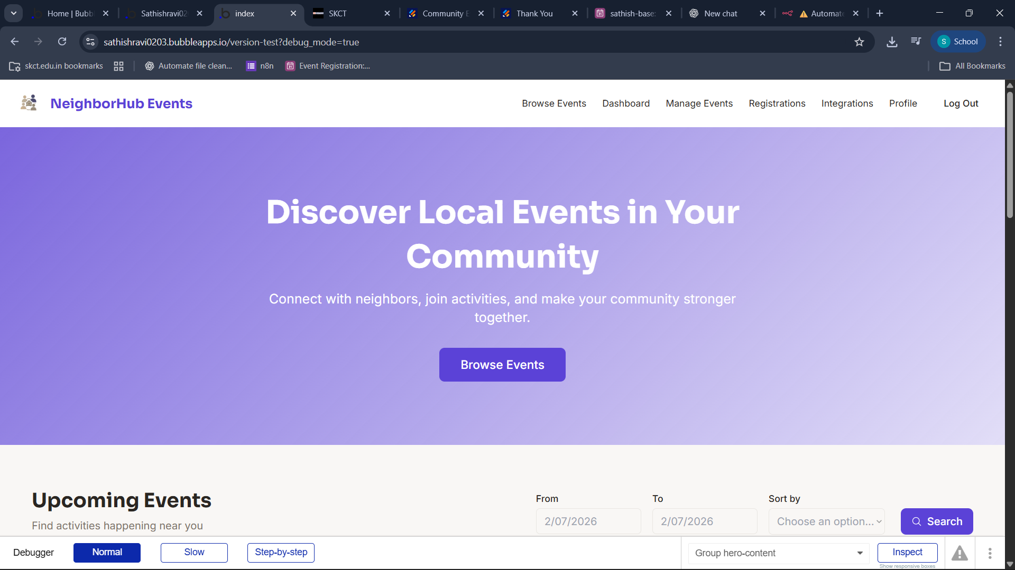
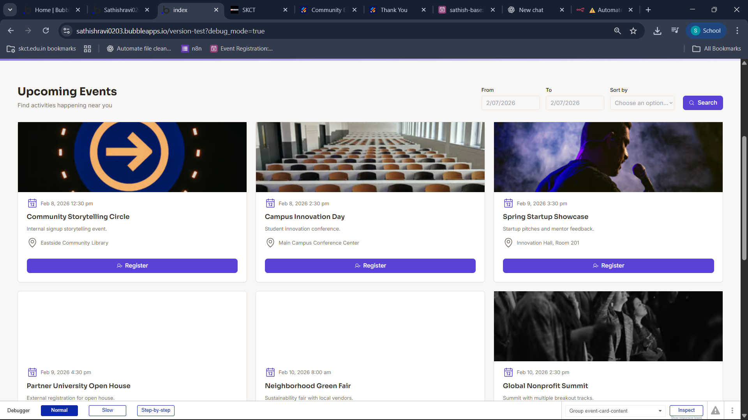
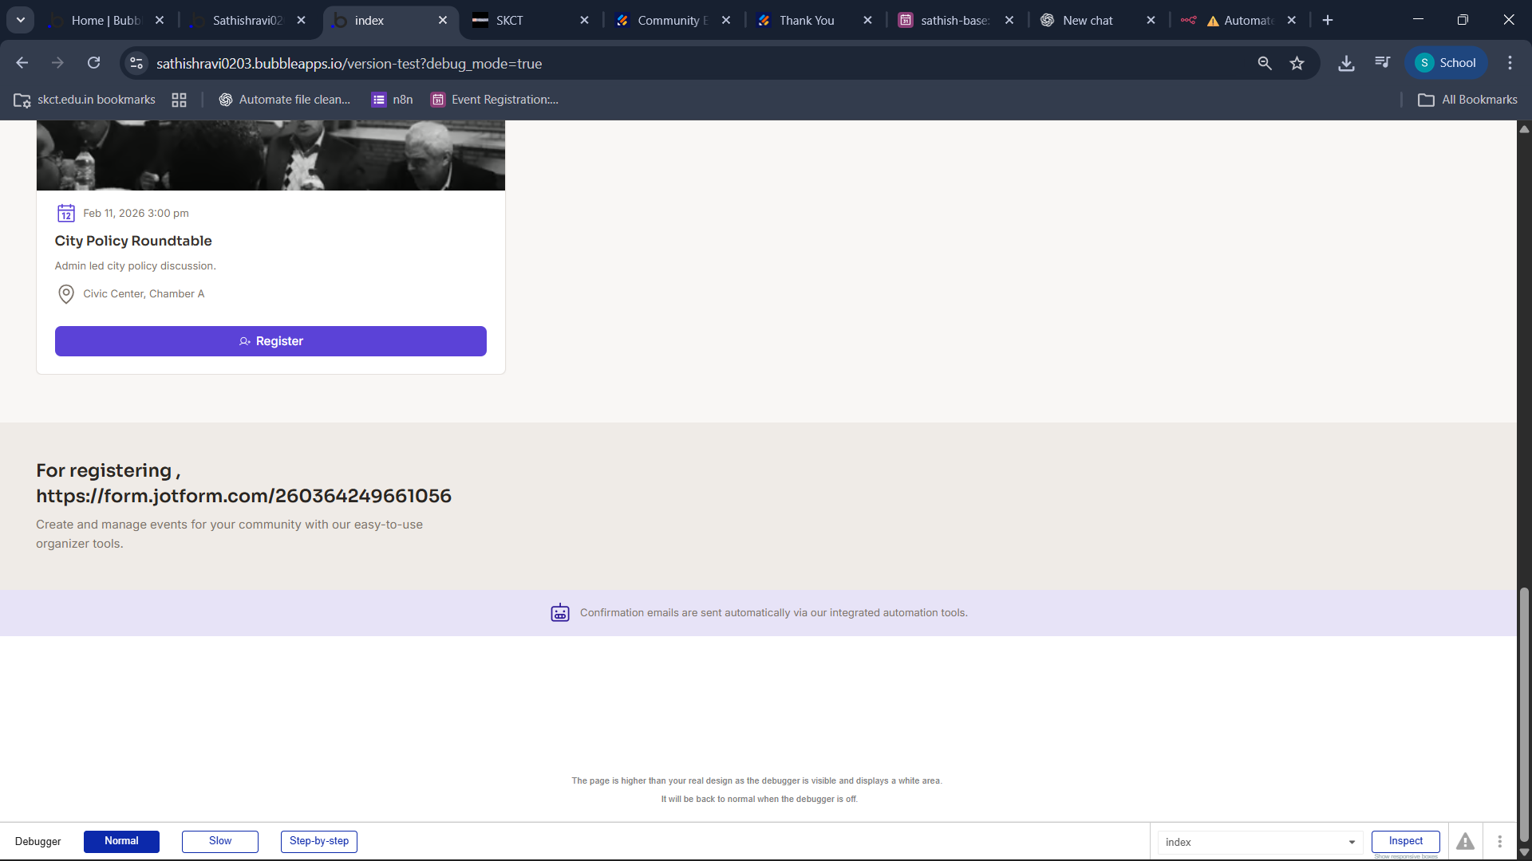

AIRTABLE :
https://airtable.com/app8zUlPFHdbqtxAA/shrHLkLXZGEtIXXaT
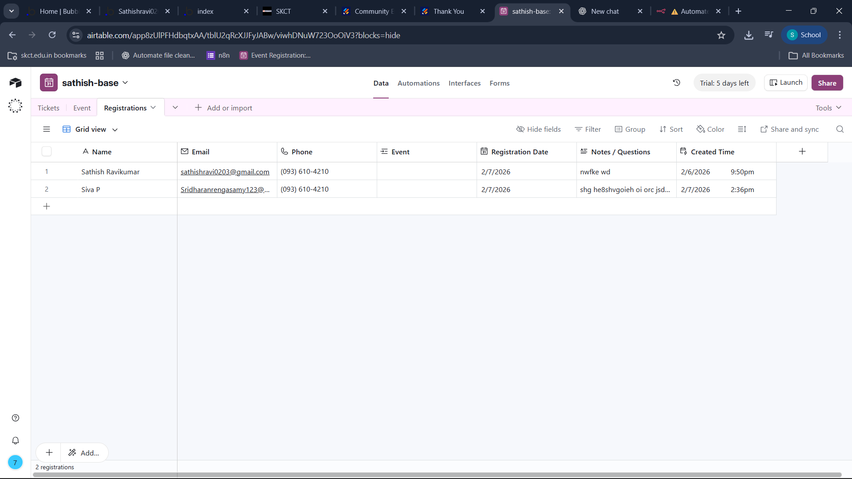
JOTFORM :
https://form.jotform.com/260364249661056

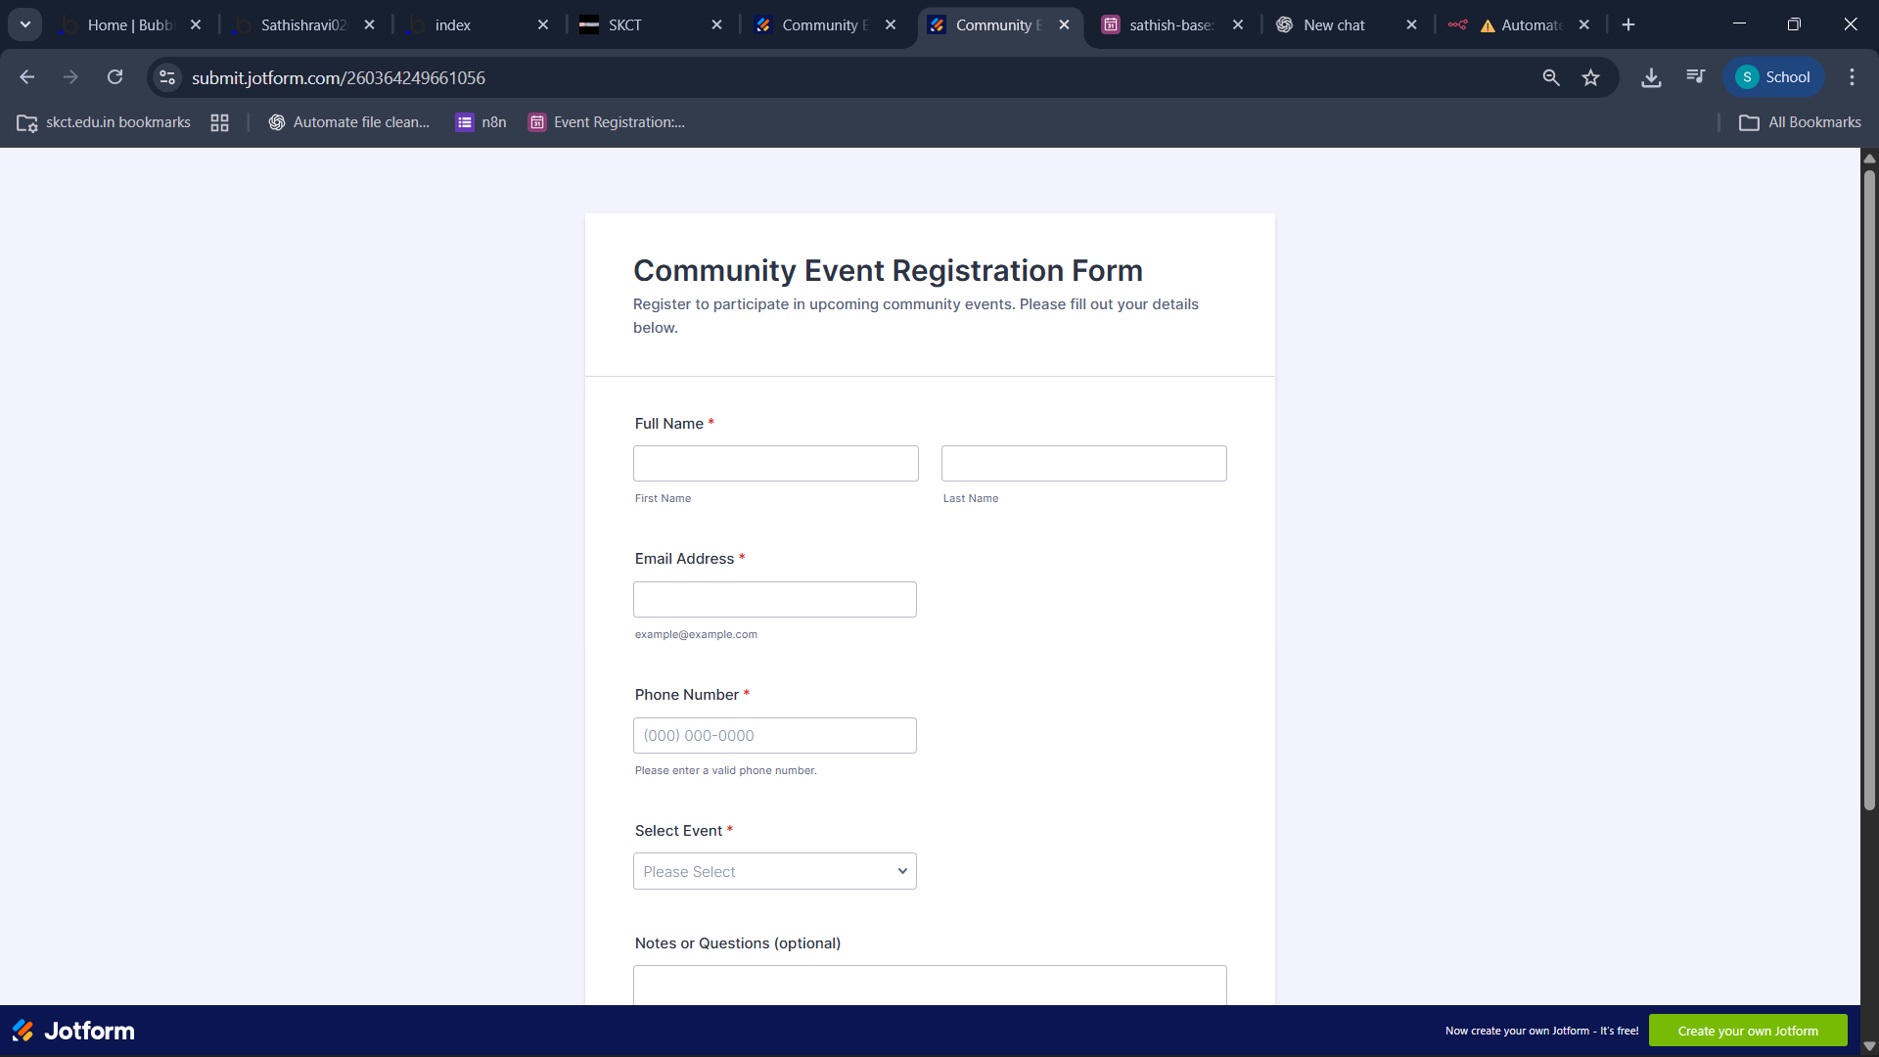
N8n automation:
https://sat23.app.n8n.cloud/workflow/Gj6gZ_jWJunhy0VeraGQh

